
<YOUR SCHOOL NAME>…

HEY STUDENTS!

HELP US STICK IT TO CANCER!

By raising money to support the Leukemia & Lymphoma Society

WHEN: <June 2 or date of your choice>

WHERE: <e.g. Basketball Court at 12 noon>

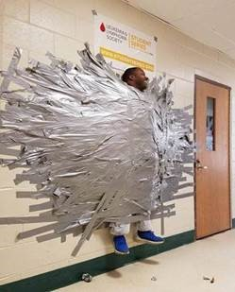

Donate $2

for strip of duct tape & help stick <Name of Volunteer(s)> to a wall!


